Version 6.0.1.3

FaxCore ev5 Installation Guide

Table of Contents
Disclaimers 3
Support 4
U.S. & Europe 4
Asia Pacific 4
System Requirements & Prerequisites 5
Operating Systems 5
Hardware Requirements 5
Supported Dialogic Brooktrout Fax Boards 5
Preparing the Server 6
Installing Dialogic Brooktrout Fax Board 6
Installing FaxCore ev5 7
Activating FaxCore ev5 10
Activate over the internet 10
Activating by phone or email (Manual Activation) 12
By phone 12
By email 12
How to obtain your installation ID 12
Activating Trial/Evaluation Mode 13
Getting started with FaxCore ev5 14
Login to FaxCore ev5 for the first time 14
Assigning Ports Licensing 14

Disclaimers

FaxCore and FaxCore ev5 are registered trademarks of FaxCore, Inc. Windows is a registered trademark of Microsoft Corporation. All other trademarks are the property of their respective owners.

Support

FaxCore customers are encouraged to purchase a FaxCore Support Contract which provides them with unlimited telephone, email and web based product support from Monday to Friday 8.00 am to 5.00 pm Mountain time (GMT -7). FaxCore Partners can also provide on-site support and training when needed. FaxCore Support Contract holders are entitled to all FaxCore product service packs and upgrades at no additional charge.

Web Support: www.faxcore.com
This site contains technical information as well as a list of frequently asked questions.

U.S. & Europe
Email Support: Email support is available at support@faxcore.com
Phone Support: FaxCore support technicians can be reached at +1 (720) 870 2900

Asia Pacific
Email Support: Email support is available at support@faxcore.com.my
Phone Support: FaxCore support technicians can be reached at +60 (3) 3324 3226

System Requirements & Prerequisites

Operating Systems
FaxCore ev5 supports the following Microsoft operating systems:
• Windows Server 2008 R2 64 bit
VMware ESX 4.0 and above, Citrix XenServer and Microsoft Hyper-V R2 virtual machines are fully supported for Dialogic Brooktrout SR140 and etherFAX implementations.
It is strongly recommended that you install a fresh and stand-alone operating system and install all
Windows Update. FaxCore ev5 installer will install the other prerequisites automatically.

Hardware Requirements

• Processor: 2.0 GHz or faster
• Memory: Minimum 2GB RAM / 4GB RAM or more recommended
• Disk Space: 4GB for FaxCore application (excluding storage for fax images and database).

Supported Dialogic Brooktrout Fax Boards

• Dialogic Brooktrout TR1034 series
• Dialogic Brooktrout TruFax series

Preparing the Server

- If you’re installing FaxCore with a physical Dialogic Brooktrout Fax Board, make sure you install the Brooktrout Fax Board on the physical server’s PCI slot prior to running FaxCore installation. (Refer to ‘Installing Dialogic Brooktrout Fax Board’)
- Copy the following files from the installation CD/download from our Customer Portal to a temporary folder on the server:
FaxCore_ev5.exe

Note: If you don’t FaxCore_ev5 Installation CD, you don’t have the installation CD, download the installation files from our
FaxCore Customer Portal: (http://crm.faxcore.com/portal/)

- On the Windows Control Panel, User Accounts, User Accounts, Change User Account Control Settings, disable the User Access Control by moving the pointer from Default to Never Notify

Installing Dialogic Brooktrout Fax Board

Note: These steps are only required if you are installing FaxCore ev5 with a Dialogic Brooktrout Fax Board.

1. Power Off the server.

2. Insert the Dialogic Brooktrout fax board into the PCI/PCIe slot.

3. Start the server. On the “New Hardware Detected” screen, click Cancel.

4. Proceed to Installing FaxCore ev5, the installation process will install the necessary drivers for the fax board.

Installing FaxCore ev5
- Make sure you have your FaxCore serial number and/or activation code prior to installing FaxCore ev5. You will not be able to proceed with the installation without the Serial Number and you will need an activation code to fully activate the software. If you don’t have your serial number/activation code, please contact your sales representative to obtain one.

- If you’re installing FaxCore ev5 with etherFAX, be sure to have your etherFAX account information ready. (Account #, Username and Password)

- Run FaxCore_ev5.exe.
- The installer will install the necessary prerequisites in order to run FaxCore ev5 software such as Microsoft Internet Information Services, Microsoft .NET Framework 3.5 and Windows PowerShell.
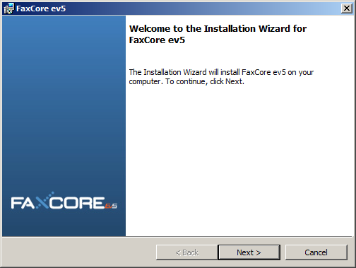

- Follow the on screen instruction until the “Customer Information” screen and enter your serial number.
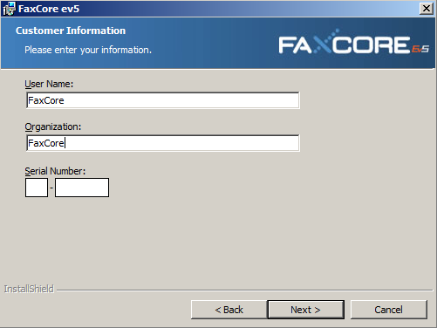
- On the next screen, confirm the installation destination and click “Next” to continue the setup process.
- Note: If you wish to change the installation destination, click on Change and browse to or enter the new installation destination of your choice.
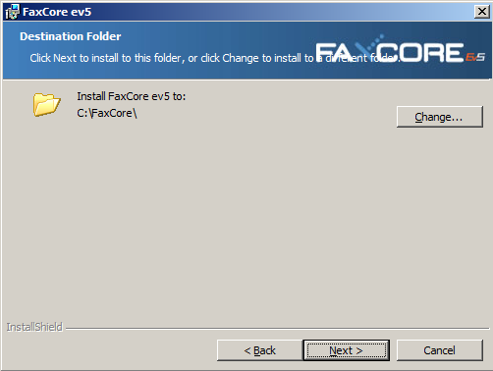

- Next you will be prompted where you want the FaxCore database to be installed.
- Note: In most cases, you will choose ‘Built-in FaxCore Database’ and this will install FaxCore ev5 database on a SQL 2008 R2 Express Edition on the local server. If you want the FaxCore database to be created and pointed to an external database, select ‘External 2005/2008 Server.
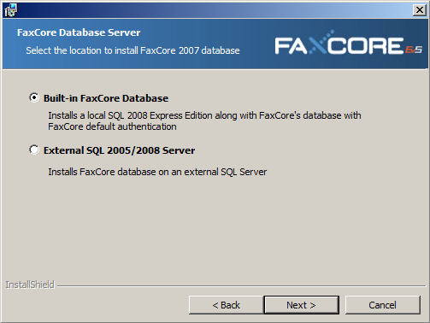

- Choose the Fax Driver Type and click “Next” to continue. At this point the Installation Wizard is ready to install FaxCore ev5.
- Note: If you choose EtherFax as your driver type, you will be prompted to enter your Account, Username and Password on the next screen. Enter the information and use the “Test Connection” button to verify that the information entered is correct before proceeding further.

- If you choose Dialogic Brooktrout as your driver type, the installer will install the necessary Dialogic Brooktrout Drivers for the installed fax board or SR140 (FOIP). At the end of the installation process, Brooktrout Configuration Utility will launch to configure and initialize the fax board/SR140
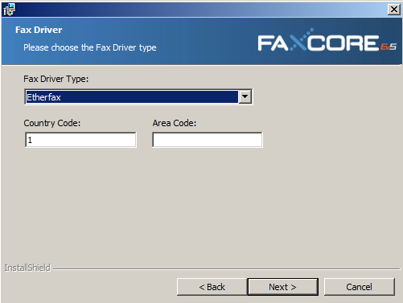

- FaxCore ev5 installer will now proceed to install Microsoft SQL 2008 R2 if you’ve selected “Built-in FaxCore database” on step 4 or create the FaxCore database on your external SQL 2005/2008 server.
- Note: On the SQL 2008 R2 installation screen, the installer will pre-populate all the required fields/configurations. Proceed through the dialogs until SQL 2008 R2 is successfully installed without changing anything.

- After FaxCore ev5 is installed, FaxCore License Manager will launch. Please see “Activating FaxCore ev5” for more information on how to activate your FaxCore ev5 software.

Activating FaxCore ev5

Activate over the internet

- Select Activate FaxCore ev5 and click “Continue”. 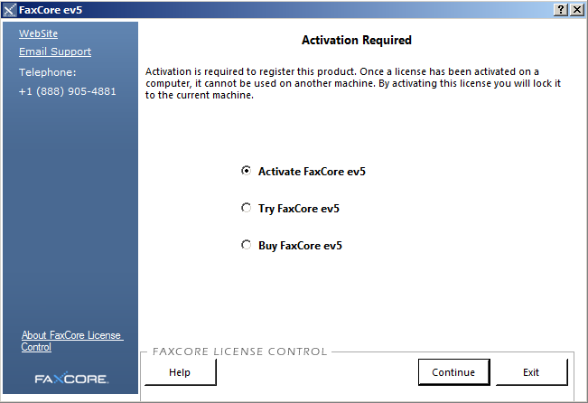
- Enter your 18 digits activation code and click “Activate”.
- Note: You will now be prompted to register your software.
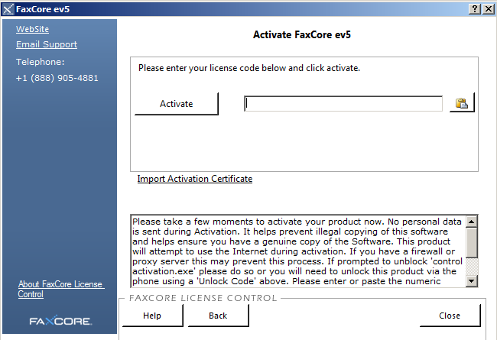

- Enter the Username and Password provided to you with your order and click register. 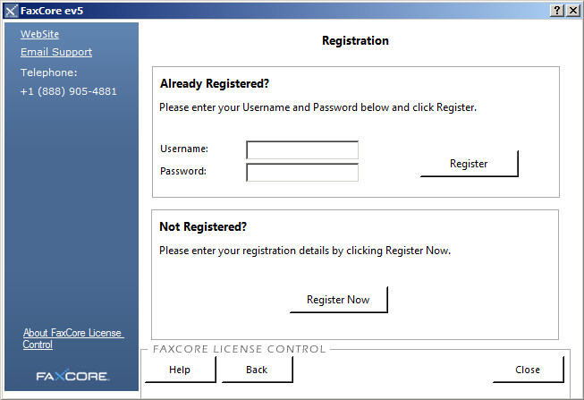
- FaxCore ev5 is now activated and ready to use.
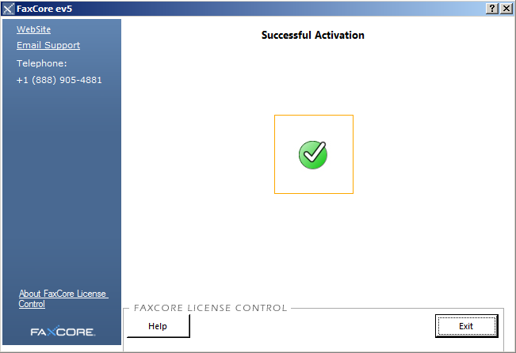

Activating by phone or email (Manual Activation)

If you do not have internet connection on the server to activate FaxCore ev5, you can activate the software by phone or email.

By phone
Call FaxCore support at +1 (888) 905-4881 and say “Technical Support” or press “2” to reach our technical support for activation assistance.

By email
Email FaxCore support at support@faxcore.com and provide us your company name, activation code and installation ID.
We will email you an activation certificate/unlock code.

How to obtain your installation ID
Click on Import Activation Certificate on the FaxCore License Manager window. 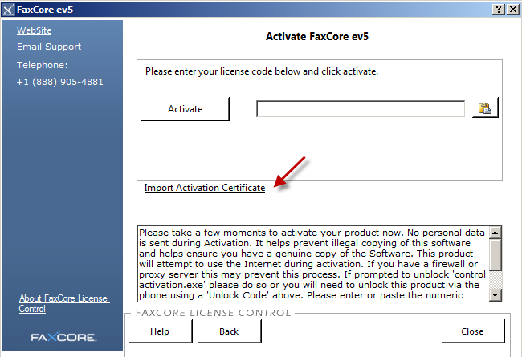

To copy the FaxCore Installation ID click on the clipboard button as show below.
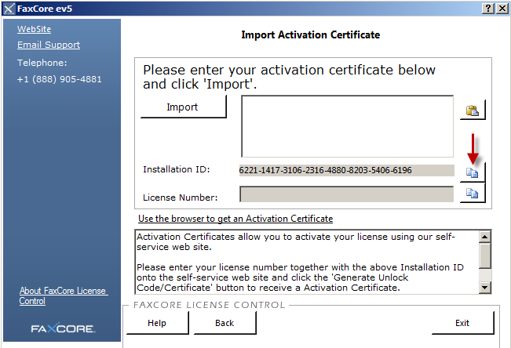

After you’re provided with the unlock code/activation certificate, paste it to the text box and click on “Import”

Activating Trial/Evaluation Mode

If you’re planning to install FaxCore for trial/evaluation purposes, simply select “Try FaxCore ev5” and on the next screen, read through our Terms and Conditions, select “accept” if you agree to our terms and conditions and “Start Trial” to begin the evaluation period.
- The trial mode gives you 45 days to evaluate the software with 2 channels/port license with all FaxCore ev5 modules enabled.

Getting started with FaxCore ev5

Login to FaxCore ev5 for the first time

1. When all the above installation process and configuration is completed, reboot the server.

2. When the server boots up, you can access the FaxCore web interface with Internet Explorer 8.0 or later at the following URLs below:

User Web Access: http://localhost/ or http://servername/
Admin Panel Access: http://localhost/admin/ or http://servername/admin/

FaxCore default Admin User Credential:

Username: admin
Password: password

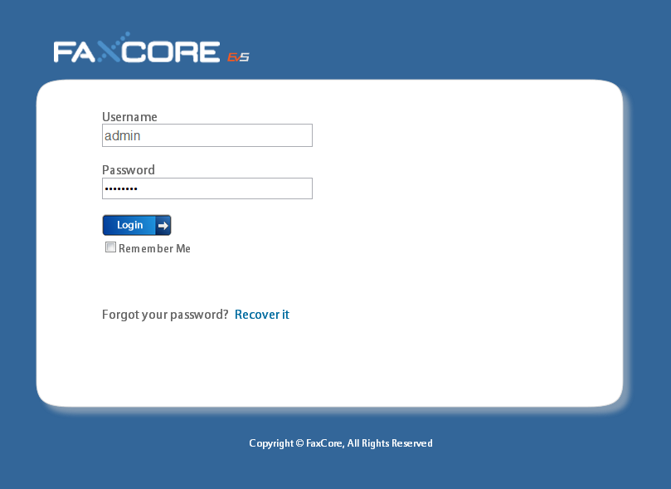

Assigning Ports Licensing

- If you have successfully activated the software or obtained a trial license by following the steps in “Activating FaxCore ev5”, you will now have FaxCore licenses available to use. You will now need to assign these licenses to the available fax ports in the system.
- To assign the licenses to enable the ports in the system, login to FaxCore ev5 Admin Panel > Network Settings > FaxAgent > License Ports tab.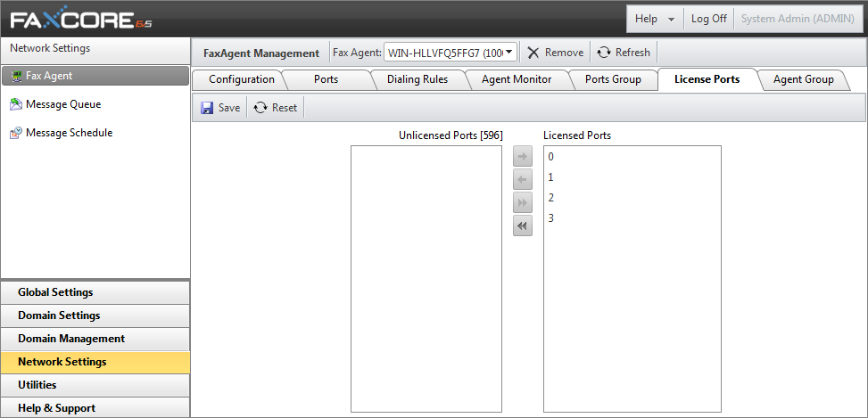
- Move the ports with >> from Unlicensed Ports section to the License Ports section and click the “Save” button.
- Next select the “Ports” tab and enable “Send” and "Receive” for the Ports that you have just assigned licenses to.
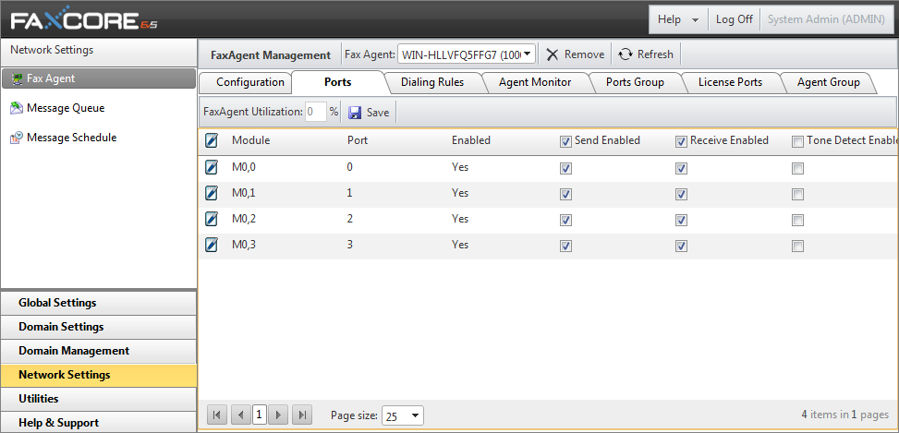

- Finally restart the “FXC3.FaxAgent” with Windows Services Management console. 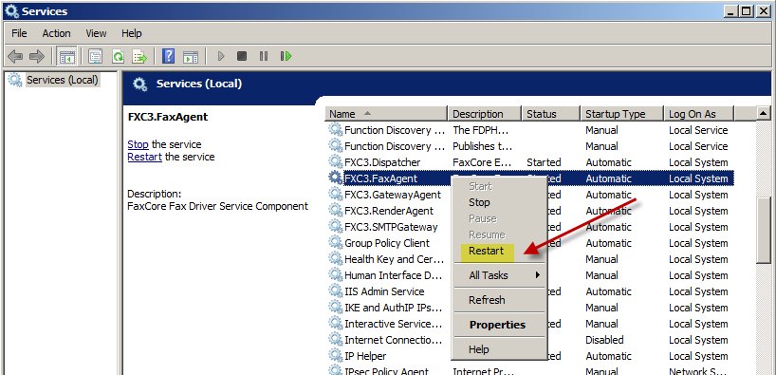

For more information, refer to FaxCore ev5 Administrator’s Guide and FaxCore ev5 User Manual.

